S

Identifying Patterns and Trends in Campus Placement Data using Machine Learning

# Project Description:

Campus recruitment is a strategy for sourcing, engaging and hiring young talent for

internship and entry-level positions. College recruiting is typically a tactic for

medium- to large-sized companies with high-volume recruiting needs, but can

range from small efforts (like working with university career centers to source

potential candidates) to large-scale operations (like visiting a wide array of colleges

and attending recruiting events throughout the spring and fall semester).Campus

recruitment often involves working with university career services centers and

attending career fairs to meet in-person with college students and recent

graduates.Our solution revolves around the placement season of a Business School

in India. Where it has various factors on candidates getting hired such as work

experience,exam percentage etc., Finally it contains the status of recruitment and

remuneration details.

We will be using algorithms such as KNN, SVM and ANN. We will train and test

the data with these algorithms. From this the best model is selected and saved in

.pkl format. We will be doing flask integration and IBM deployment.

# Empathy map:

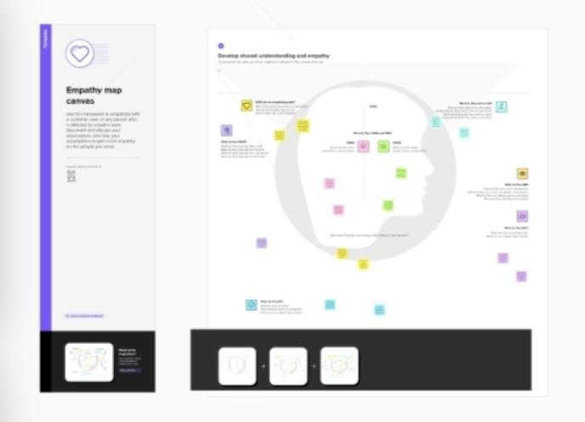

# Brainstroming:

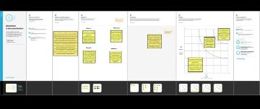

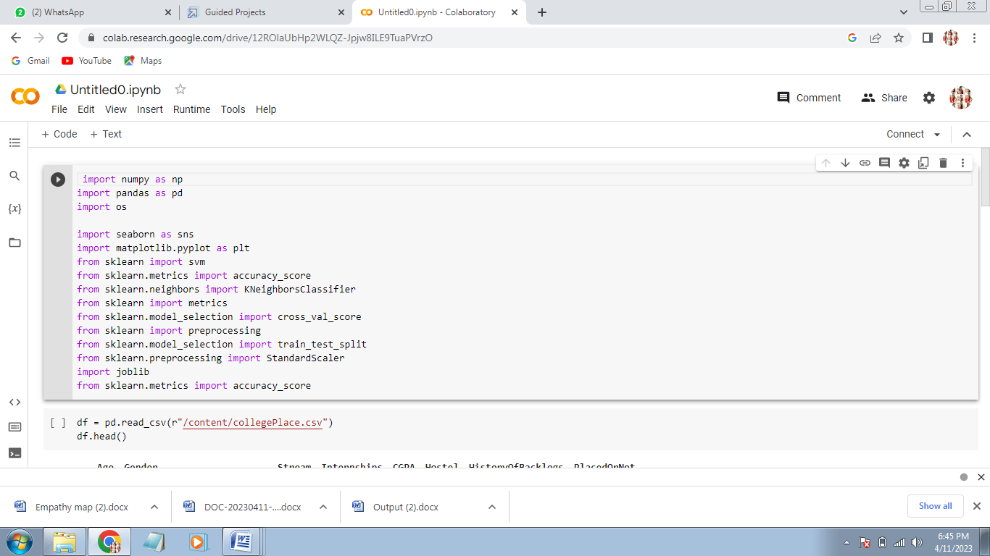

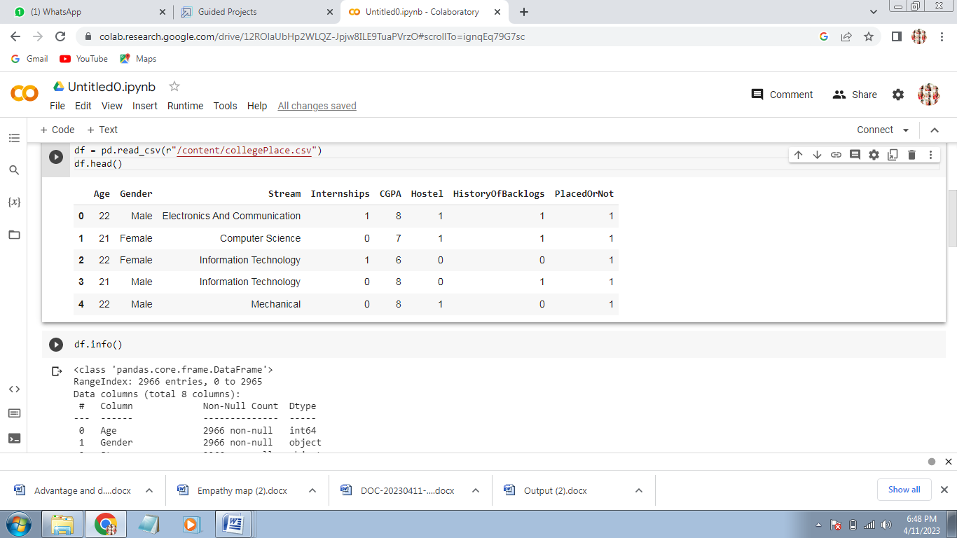

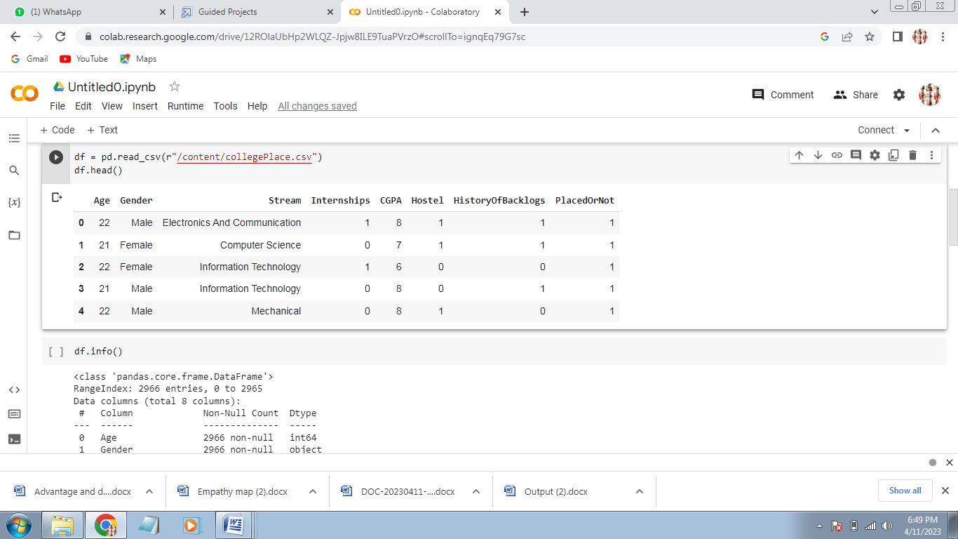

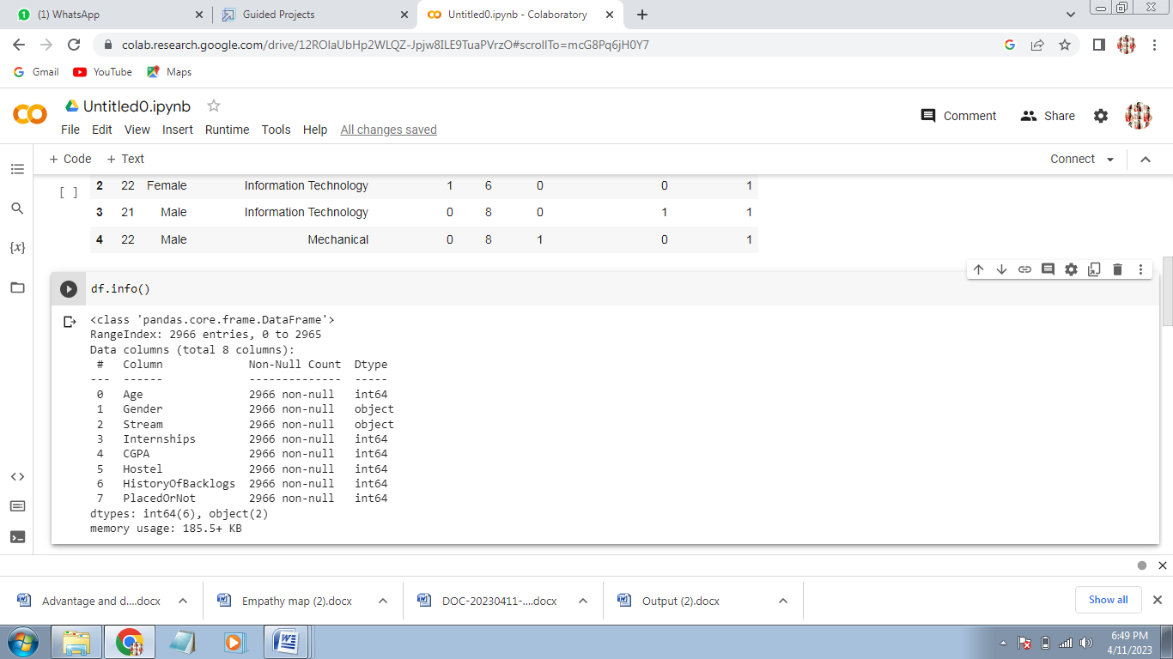

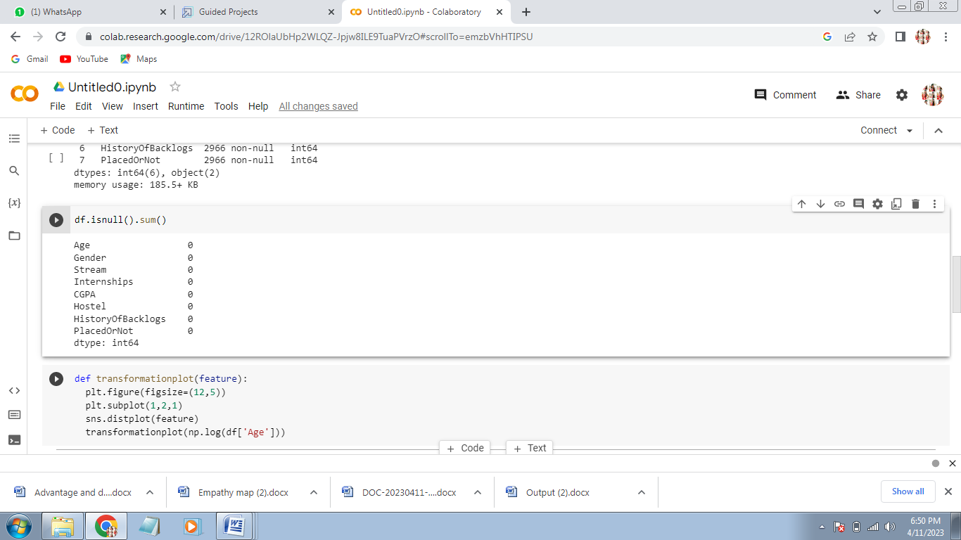

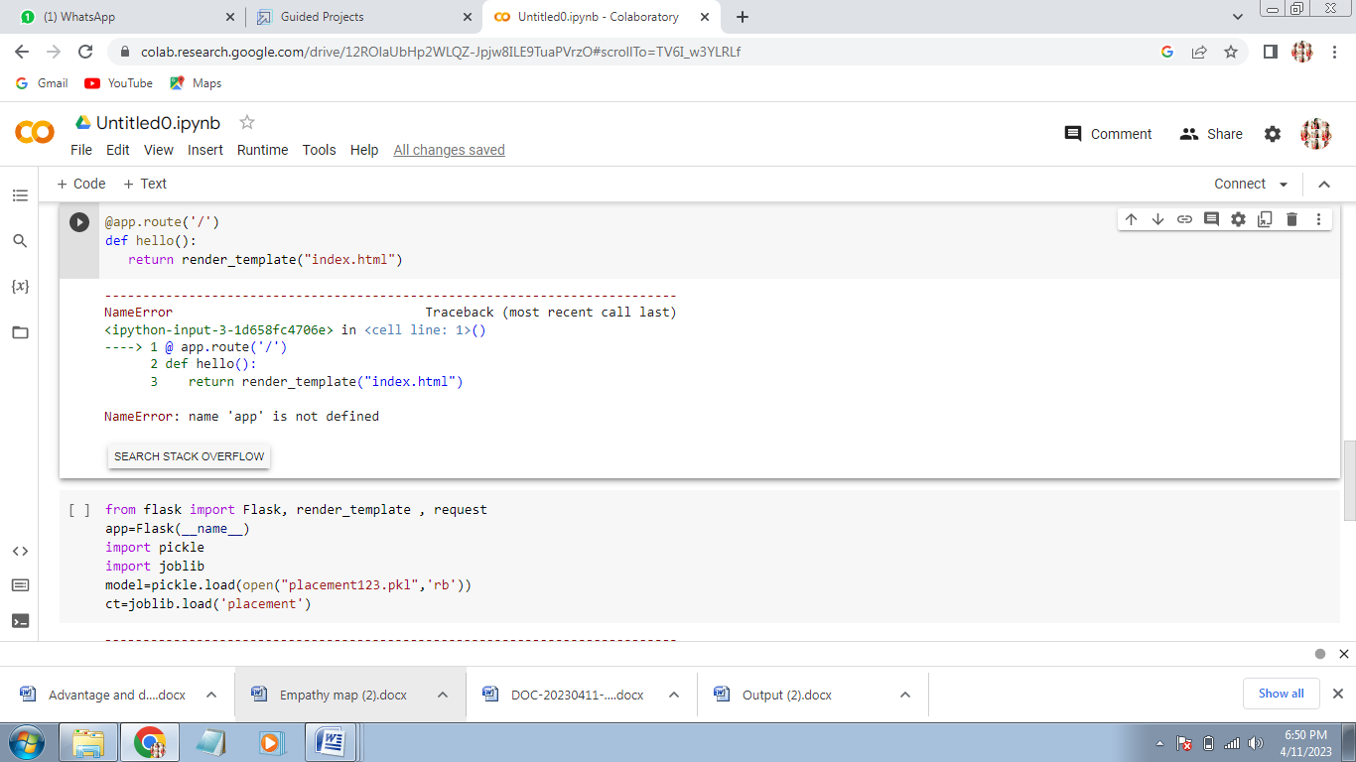

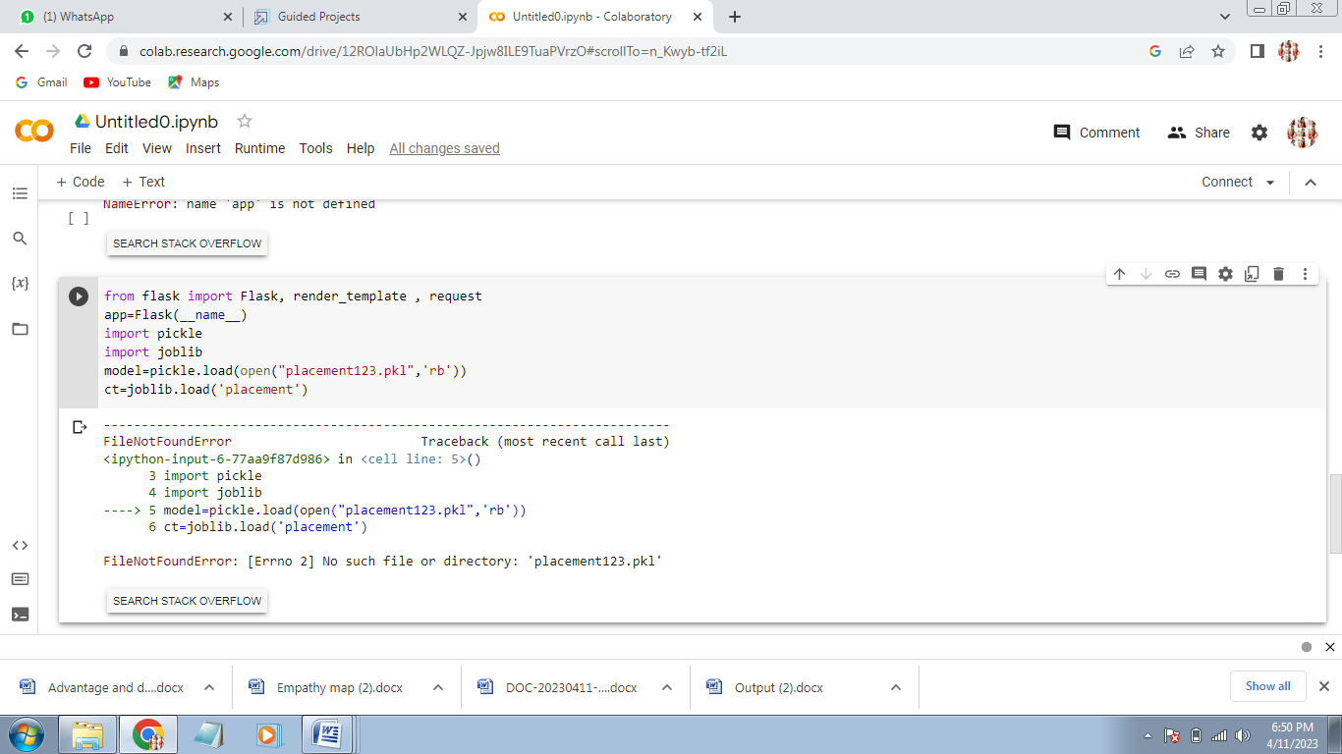

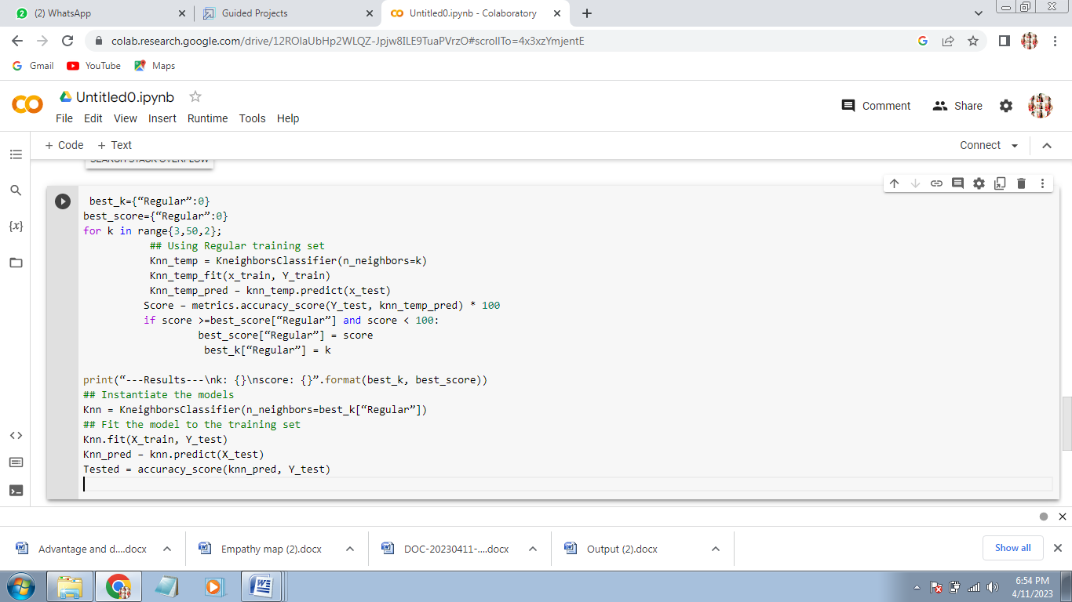

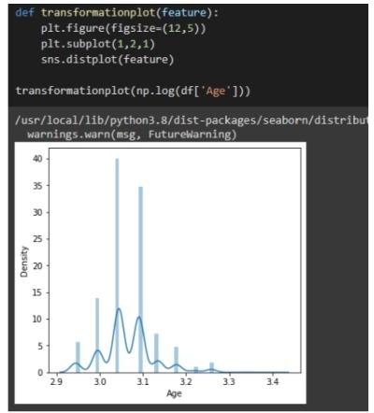



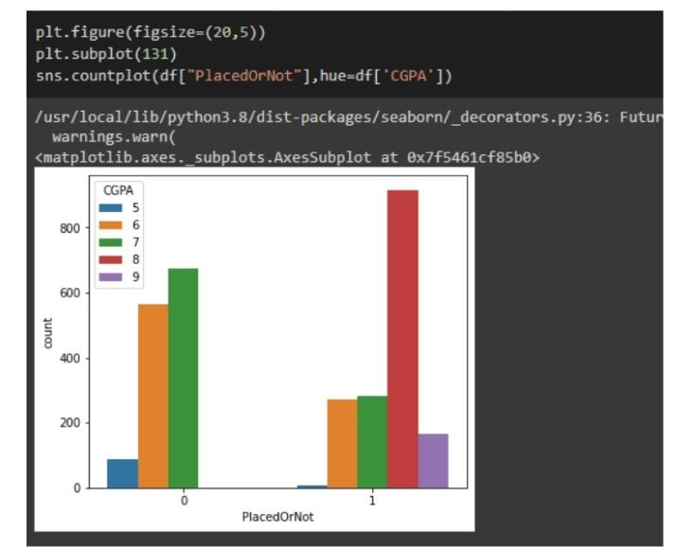

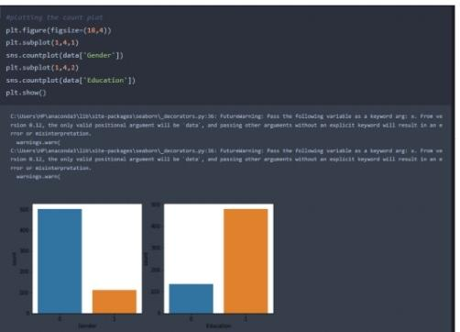

# Advantage and disadvantage:

Campus recruitment includes specific advantages and disadvantages. Main advantage of campus placement is that it is possible for companies to select best, quality candidates within short time duration. Students can have the advantage of getting a reputed job even before completion of their academic course in college. Increased selection ratio, building company loyalty among students, etc is some other possible advantages. The main disadvantages of campus recruitment are incurred high expenses for companies (in recruitment and training). https://entrance-exam.net/campus-recruitment-advantages-and-disadvantages/

Advantages of Campus Recruitment

Campus recruitment activity offers several advantages to both the companies as well as the job applicants. Following are some of the main advantages of campus recruitment listed below -

The companies will be benefited from getting wide choice of candidates to select for different job posts. Companies can select the right and talented candidate from a vast pool of young applicants within a limited time. On the other hand, students have the advantage of getting a good job according to their qualification level even before the completion of their academic course in college.

Campus recruitment helps in saving time and efforts of the companies. The entire campus recruitment process from a college is not a tedious toil. It prevents the occurrence of unusual expenditures related to recruitment process such as advertisement, initial screening, and final selection procedures etc. This in turn turns to be useful in reduced manpower effort and time as well.

An organization through effective campus recruitment finds an opportunity to establish a link with the next batch of students. This in turn paves way to serve the future and long term recruitment needs of the company. Students participating in internships and summer training programs may have direct recruitment to different job positions offered by the company.

Campus recruitment helps in increased selection ratio. More number of quality candidates can be selected through this recruitment process.

The organizations can built up more company loyalty through campus selection process. Fresh and talented graduates will work more closely with their first company. Hence, this in a way will increase the brand loyalty among different applicants.

# Disadvantages of Campus Recruitment:

Campus recruitment is an expensive affair for majority of the companies as it adds up costs to the bottom line. Companies incur different expenses related to travel, boarding, training etc while conducting campus selection process. The experienced and skilled candidates having practical job exposures cannot be recruited through campus placements. Fresh candidates selected through campus placements require adequate training for work. This is an additional expense for the company.  Also, students can’t work with their dream company and will have to remain satisfied with the company that recruits them during campus selection. https://entrance-exam.net/campus-recruitment-advantages-and-disadvantages/

# Application:

1. Apply with a crisp and clear resume:

Resume plays a crucial role in your job search and is the perfect medium to showcase your qualities and skills.

The resume must be designed to get special attention as it is your ticket to get shortlisted for a job interview.

So, the first thing you need to do for campus recruitment is to build a strong and crisp resume that highlights all your achievements- both academic and extra-curricular.

Your CV should be tailor-made to the requirements of the job you are interviewing for.

Here are some things you must include in your resume:

1. [A strong resume headline](https://www.naukri.com/blog/resume-headline-for-freshers/?utm_content=naukriblog/)
2. [A clear career objective](https://www.naukri.com/blog/career-objective-for-freshers/?utm_content=naukriblog/)
3. [Profile summary](https://www.naukri.com/blog/profile-summary-freshers-samples/?utm_content=naukriblog/)
4. [Skills that make you a good fit for the job](https://www.naukri.com/blog/skills-for-resume-3/?utm_content=naukriblog/)
5. [Academic references](https://www.naukri.com/blog/how-to-list-references-on-resume/?utm_content=naukriblog/)
6. [A good format for your CV](https://www.naukri.com/blog/pro-tips-to-get-your-cv-format-right/?utm_content=naukriblog/)

Also read: [10 Things A Recruiter Looks for in Your CV](https://www.naukri.com/blog/10-things-a-recruiter-looks-for-in-your-cv/?utm_content=naukriblog/)

*Tip: Keep it to the point as your resume should be no longer than 1-2 pages.*

2.**[Research the company](https://www.ambitionbox.com/" \t "_blank)**:

Before preparing for an interview, it is very important that you thoroughly research the company.

Doing this will help you prepare better and will also let you know if the company is the right fit for you.

Here are a few factors to check for a sound research:

1. Company reviews and ratings by employees on websites like [AmbitionBox](https://www.ambitionbox.com/" \o "" \t "_blank)
2. Additional perks and benefits offered by the company
3. The company's vision and mission statement
4. The company culture
5. Low retention rate.
6. [Salary insights of the company](https://www.ambitionbox.com/salaries)

[Interview questions to prepare for the interview](https://www.ambitionbox.com/interviews)

# [Prepare for interview questions](https://www.naukri.com/blog/top-interview-questions-and-answers-for-freshers/?utm_content=naukriblog/):

Interviews are nerve-wracking, especially if it’s your first. But there is nothing that practice cannot perfect.

So, get ready for some intense placement preparation with important questions that are commonly asked in interviews.

Some of these questions are:

1. [Tell me about yourself](https://www.naukri.com/blog/tell-me-about-yourself-hr-interview-question-answers/?utm_content=naukriblog/)
2. [What are your strengths and weaknesses?](https://www.naukri.com/blog/what-are-your-strengths-and-weaknesses-interview-question/?utm_content=naukriblog/)
3. [What motivates you to work hard?](https://www.naukri.com/blog/what-motivates-you-to-do-a-good-job-sample-answers-to-this-hr-interview-question/?utm_content=naukriblog/)
4. [Are you a team player?](https://www.naukri.com/blog/how-to-answer-are-you-a-team-player-with-sample-answers/?utm_content=naukriblog/)
5. [Why do you want to work for our company?](https://www.naukri.com/blog/how-to-answer-why-do-you-want-to-join-our-company/?utm_content=naukriblog/)
6. [Where do you see yourself in five years?](https://www.naukri.com/blog/where-do-you-see-yourself-five-years-from-now-sample-answers-to-this-hr-interview-question-utm_source-naukri-utm_medium-undefined-utm_campaign-naukri_blogs/?utm_content=naukriblog/)
7. [Describe yourself in one word](https://www.naukri.com/blog/how-to-describe-yourself-in-one-word/?utm_content=naukriblog/)

While preparing for campus recruitments, make sure you practice your tone, speech, and make a list of points to include.

However, do not stick to the script and answer in a conversational manner.

# [Practice with mock interviews](https://www.naukri.com/blog/how-to-stay-at-home-and-prepare-for-a-mock-interview-covid-article3/?utm_content=naukriblog/):

Reading and preparing is just not enough when it comes to placement preparation.

If you are someone who gets nervous about interviews and wants to ace campus recruitment, all you need is a lot of practice before the real deal.

And the best way to do it is through mock interviews.

The good news is you can practice mock interviews for free on websites like [Pramp](https://www.pramp.com/" \l "/" \o "" \t "_blank), [InterviewBit](https://www.interviewbit.com/" \o "" \t "_blank), [interviewing.io](https://interviewing.io/), and [Prepbunk](https://www.prepbunk.com/" \o "" \t "_blank).

In case you don’t wish to experiment online, you can also ask your friends/family to interview you and give feedback on your answers.

5.**[Practice for all kinds of interviews](https://www.naukri.com/blog/types-of-interviews-and-how-to-ace-them/?utm_content=naukriblog/" \t "_blank)**:

Campus recruitments are different from regular interviews, and you may have to go an extra mile as you prepare

Many campus recruitments begin with a [group discussion](https://www.naukri.com/blog/group-discussion-tips-you-must-know/?utm_content=naukriblog/)where companies interview 8-10 people together based on their performance.

The idea is to skim the cream and find candidates who showcase leadership qualities and reasoning.

In a [panel interview](https://www.naukri.com/blog/how-to-tackle-a-panel-interview/?utm_content=naukriblog/), you face not one but 2-4 interviewers who screen you for the job opportunity.

It is to judge you under immense pressure. Panel interviews are often used interchangeably with group discussion, but follow a more formal approach.

Face-to-face interviews are simple one on one sessions where an interviewer screens your candidature for the profile and assesses your suitability.

# Conclution:

Campus recruiting is usually a multi-step process that includes campus targeting, pre-placement activities through college internships, assessment, interviewing, and boarding. Campus recruitment aims to have access to an immense pool of recent graduates looking for work. This helps most companies meet their expanding talent demands by employing applicants from different educational institutions.

# Futhure scope:

Campus placement or campus recruiting is a program conducted within universities or other educational institutions to provide jobs to students nearing completion of their studies. In this type of program, the educational institutions partner with corporations who wish to recruit from the student population.